STRING
1. String example
package padma;
public class StringExample {
public static void main(String args[]){
String s1="java";//creating string by java string literal
char ch[]={'s','t','r','i','n','g','s'};
String s2=new String(ch);//converting char array to string
String s3=new String("example");//creating java string by new keyword
System.out.println(s1);
System.out.println(s2);
System.out.println(s3);
}}
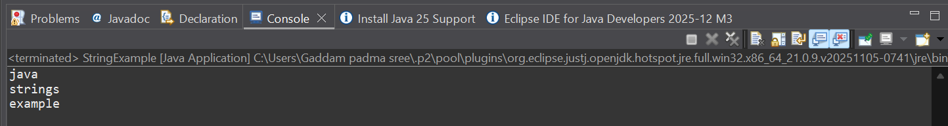
2. LowercaseToUppercase
package padma;
public class UppercaseToLowercase {
public static void main(String[] args) {
String s = "Sachin";
System.out.println(s.toUpperCase());
System.out.println(s.toLowerCase());
System.out.println(s);
}
}
3. String Trim
package padma;
public class StringTrim {
public static void main(String[] args) {
String s=" Sachin ";
System.out.println(s);
System.out.println(s.trim());
}
}
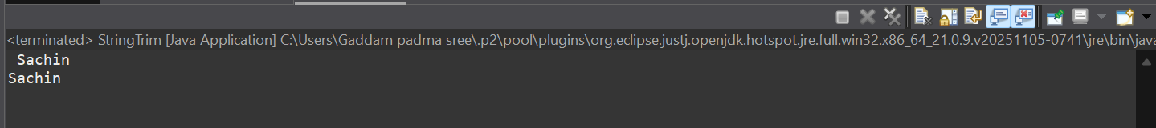

4. StartsAndEndswith
package padma;
public class StartsAndEndsWith {
public static void main(String[] args) {
String s = "Sachin";
System.out.println(s.startsWith("Sa"));
System.out.println(s.endsWith("n"));
}
}
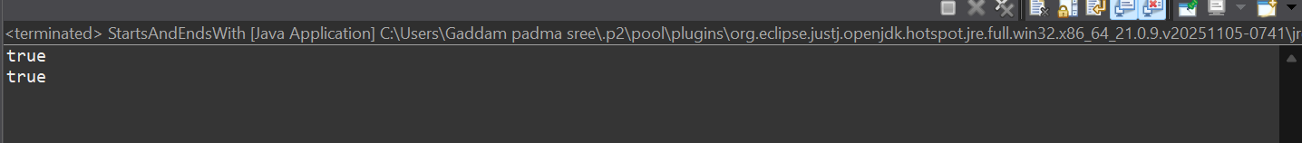
5. CharAtMethod
package padma;
public class CharAtMethod {
public static void main(String[] args) {
String s = "Sachin";
System.out.println(s.charAt(0));
System.out.println(s.charAt(3));
}
}
6. StringLength
package padma;
public class StringLength {
public static void main(String[] args) {
String s = "Sachin";
System.out.println(s.length());
}
}

7. InternValueReplace
package padma;
public class InternValueReplace {
public static void main(String[] args) {
String s = new String("Sachin");
String s2 = s.intern();
System.out.println(s2);
int a = 10;
String s3 = String.valueOf(a);
System.out.println(s3 + 10);
String s1 = "Java is a programming language. Java is a platform. Java is an Island.";
String replaceString = s1.replace("Java", "Kava");
System.out.println(replaceString);
}
}
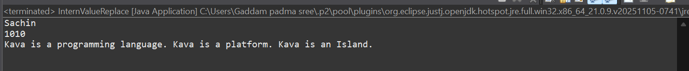
8. ConcatPlus
package padma;
public class ConcatPlus {
public static void main(String[] args) {
String s = "Sachin" + " Tendulkar";
System.out.println(s);
}
}
9.ConcatMethod
package padma;
public class ConcatMethod {
public static void main(String[] args) {
String s1 = "Sachin ";
String s2 = "Tendulkar";
String s3 = s1.concat(s2);
System.out.println(s3);
}
}
10. EqualsMethod
package padma;

public class EqualsMethod {
public static void main(String[] args) {
String s1 = "Sachin";
String s2 = "Sachin";
String s3 = new String("Sachin");
String s4 = "Saurav";
System.out.println(s1.equals(s2));
System.out.println(s1.equals(s3));
System.out.println(s1.equals(s4));
}
}
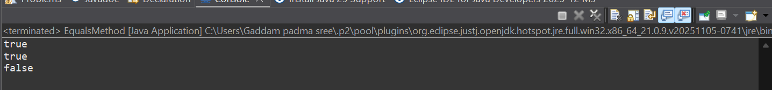

11. DoubleEquals
package padma;

public class DoubleEquals {
public static void main(String[] args) {
String s1 = "Sachin";
String s2 = "Sachin";
String s3 = new String("Sachin");
System.out.println(s1 == s2);
System.out.println(s1 == s3);
}
}
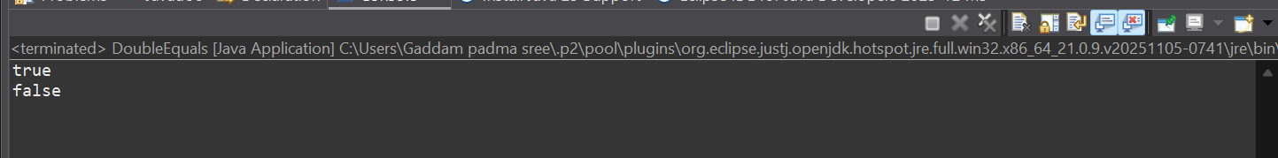

12. CompareTo
package padma;
public class CompareTo {
public static void main(String[] args) {
String s1 = "Sachin";
String s2 = "Sachin";
String s3 = "Ratan";
System.out.println(s1.compareTo(s2));
System.out.println(s1.compareTo(s3));
System.out.println(s3.compareTo(s1));
}
}
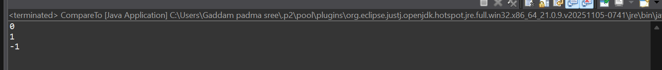
STRING BUFFER
1. append()
package padma;
class StringBufferAppend{
public static void main(String args[]) {
StringBuffer sb = new StringBuffer("Hello ");
sb.append("Java");
System.out.println(sb);
}
}
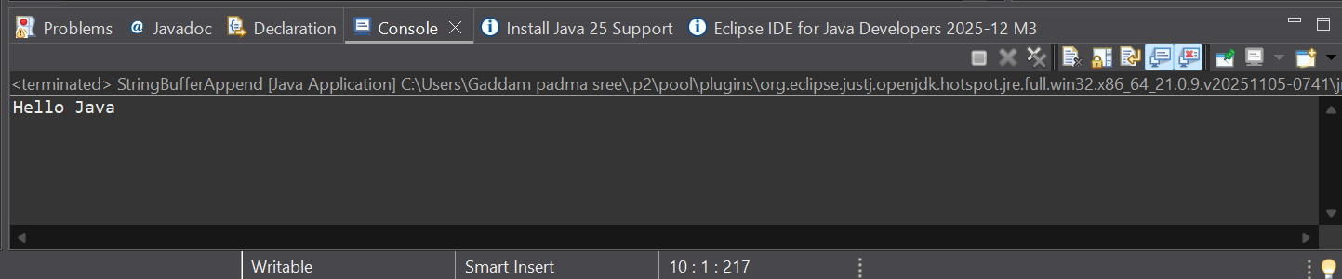
2. Insert
package padma;
class StringBufferInsert {
public static void main(String args[]) {
StringBuffer sb = new StringBuffer("Hello ");
sb.insert(1, "Java");
System.out.println(sb);
}
}
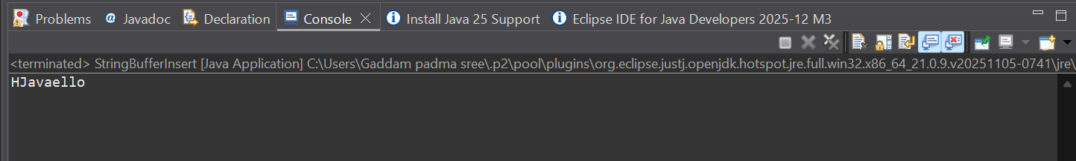
3. Replace()
package padma;
public class StringBufferReplace {
public static void main(String args[]){
StringBuffer sb=new StringBuffer("Hello");
sb.replace(1,3,"Java");
System.out.println(sb);
}
}
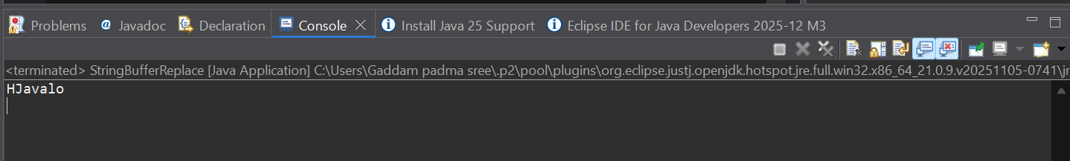
4. Delete()
package padma;

public class StringBufferDelete {
public static void main(String args[]){
StringBuffer sb=new StringBuffer("Hello");
sb.delete(1,3);
System.out.println(sb);
}
}
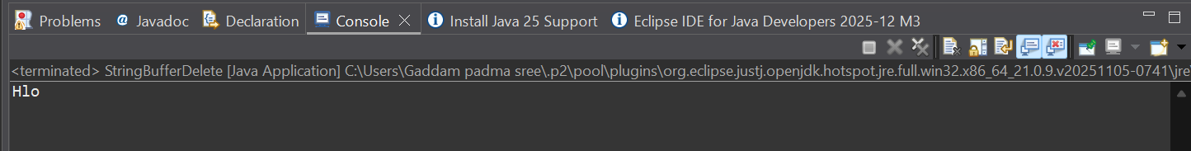
5. Reverse()
package padma;
public class StringBufferReverse {
public static void main(String args[]){
StringBuffer sb=new StringBuffer("Hello");
sb.reverse();
System.out.println(sb);
}
}
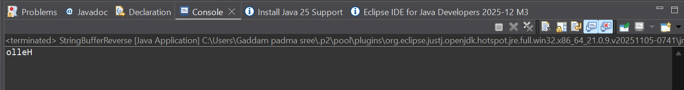
STRING BUILDER
1. Append()
package padma;
public class StringBuilderAppend {
public static void main(String args[]){
StringBuilder sb=new StringBuilder("Hello ");
sb.append("Java");//now original string is changed
System.out.println(sb);
}
}
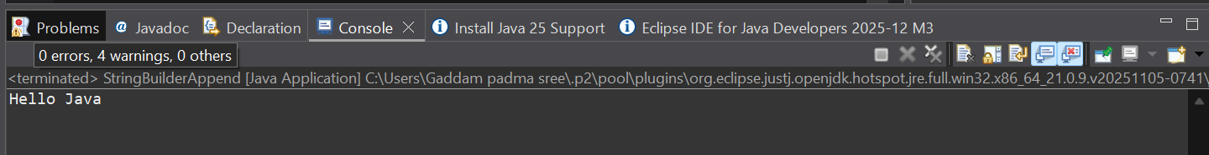
2. Insert()
package padma;
public class StringBuilderInsert {
public static void main(String args[]){
StringBuilder sb=new StringBuilder("Hello ");
sb.insert(1,"Java");//now original string is changed
System.out.println(sb);
}
}
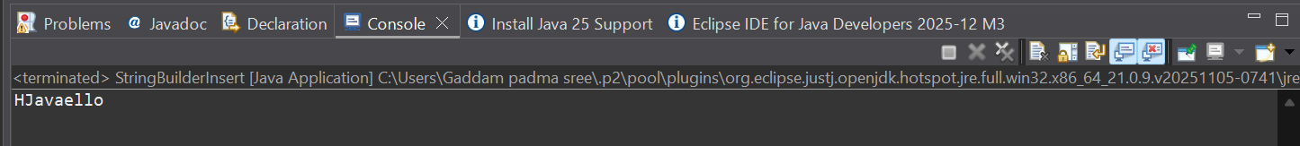
3. Replce()
package padma;
public class StringBufferReplace {
public static void main(String args[]){
StringBuffer sb=new StringBuffer("Hello");
sb.replace(1,3,"Java");
System.out.println(sb);
}
}
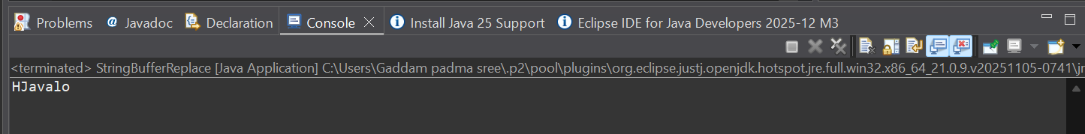
4. Delete()
package padma;
public class StringBuilderdelete {
public static void main(String args[]){
StringBuilder sb=new StringBuilder("Hello");
sb.delete(1,3);
System.out.println(sb);
}
}
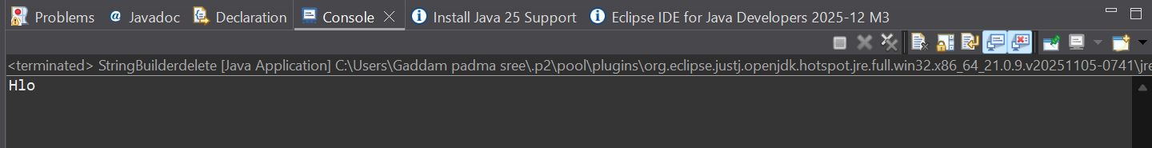
5. Reverse()
package padma;
public class StringBuilderReverse {
public static void main(String args[]){
StringBuilder sb=new StringBuilder("Hello");
sb.reverse();
System.out.println(sb);//prints
}
}
